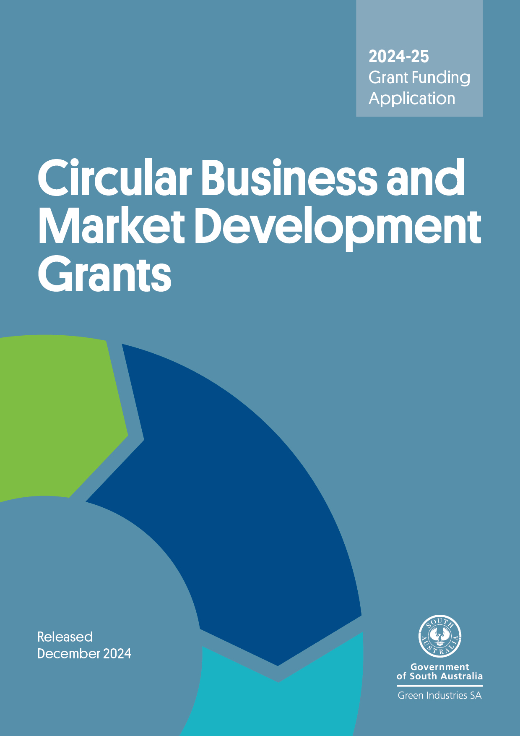

**Program overview**

The Circular Business and Market Development Grant program aims to assist businesses, local authorities, industry groups, not-for-profit organisations, social enterprises and research institutions to accelerate the transition to a more circular economy via supporting adoption of, upscaling, increased market confidence and acceptance of innovative and commercial circular economy business models, solutions and practices as well as refurbished/repaired or recycled content products.

**Submitting your application**

Applications will be accepted until **5 pm ACDT, Friday 31 January 2025**. **No late applications will be accepted.**

Please email your completed application form, with a signed declaration, including all supporting documents to [serena.yang@sa.gov.au](mailto:serena.yang@sa.gov.au) with subject line **Circular Business and Market Development Grant – application**. Emails should not exceed 10MB.

**Checklist**

Before submitting your application, please check you have completed all the following:

☐ Read the Circular Business and Market Development Grant Guidelines 2024–25 in detail

☐ Completed the application form in full

☐ Signed the declaration

☐ Attached copies of a Certificate of Currency for insurance (as required) and all supporting documents.

**Need assistance?**

Email [serena.yang@sa.gov.au](mailto:serena.yang@sa.gov.au) for more information and/or to check your eligibility.

**Section A: General Information**

|  |  |  |  |
| --- | --- | --- | --- |
| A1. Name of Organisation (or the lead organisation administering the project if the proposal is submitted by a partnership) | | | |
| Registered business name: | | | |
| Trading name (if any): | | | |
| A2. Business registrations | | | |
| Australian Business Number (ABN): | | | |
| Australian Company Number (ACN): | | | |
| **A3. Is your organisation registered for GST?** | | | |
| ☐Yes ☐No | | | |
| **A4. Business address** | | | |
| Street address: | | | |
| Suburb: State: Postcode: | | | |
| Your postal address if different from your business address | | | |
| Street address: | | | |
| Suburb: State: Postcode: | | | |
| A5. What is the legal status of your organisation? (Select only ONE box) | | | |
| ☐Proprietary limited company ☐Incorporated association | | | |
| ☐Company limited by guarantee ☐Other (please detail) | | | |
| **A6. Primary contact details** | | | |
| Name: |  | Position: | |
| Tel: |  | Mobile: | |
| Email: |  | Web: | |
| **A7. Name of partner organisation and contractors for this application (if any)** | | | |
| **Partner 1** | | | |
| Name: | | | |
| Address: | | | |
| **Partner 2** | | | |
| Name: | | | |
| Address: | | | |
| **Partner 3** | | | |
| Name: | | | |
| Address: | | | |
| **A8. Insurance (please attach copies of Certificates of Currency as required)** | | | |
| **A9. Applicant background** | | | |
| How long has your organisation been in operation? | | |  |
| How many FTEs does the organisation currently employ? | | |  |
| How many FTEs are based in South Australia? | | |  |
| Annual turnover for the last 2 financial years? | | | 2022–23: $ |
| 2023–24: $ |
| Briefly describe the core business of your organisation (e.g. your product or service, market segment and major customers etc): | | | |

**Section B: Eligibility Criteria Checklist**

|  |  |  |
| --- | --- | --- |
| **To be eligible for funding the applicant must meet all eligibility criteria below** | | |
|  | **Yes** | **No** |
| **B1. Will the applicant be implementing the project whereby the primary focus and benefits are for, and remain within, South Australia?** | ☐ | ☐ |
| **B2. Is the applicant solvent and able to enter into a legally binding funding agreement with the South Australian Government?** | ☐ | ☐ |
| **B3. Does the applicant have a current Australian Business Number and registered for GST and complied with all federal and state laws, regulations and any applicable Environment Protection Authority requirements?** | ☐ | ☐ |
| **B4. Has the applicant been operating for a minimum of 2 years?\*** | ☐ | ☐ |
| **B5. Does the applicant have operations in South Australian for the duration of the proposed project (e.g. have an office or staff based in South Australia)?** | ☐ | ☐ |

*Applications from applicants who have been operating for less than 2 years may be considered on a case-by-case basis if sufficient justification is provided.

|  |  |  |
| --- | --- | --- |
| **To be eligible for funding the project must meet all eligibility criteria below** | | |
|  | **Yes** | **No** |
| B6. Does the proposed project meet and contribute to the objectives and aims of:   * The *South Australia’s Waste Strategy 2020-2025* and * The Circular Business and Market Development Grant Program 2024–25? | ☐  ☐ | ☐  ☐ |
| B7. Does the proposed project demonstrate the need for government funding for at least one of the below three focus areas?   * Identify, design, apply and/or scale-up innovative circular economy business models, solutions and practices * Validate and improve the transparency, quality and performance of local refurbished/repaired or recycled-content products * Develop new markets or expand existing markets for circular economy business models, solutions and practices or refurbished/repaired or recycled-content products | ☐  ☐  ☐ | ☐  ☐  ☐ |
| B8. Does the project target the identified waste materials?  The identified priority waste materials are plastics, textiles, food waste and organics, e-waste, batteries (excluding used lead acid batteries), paper and cardboard, glass, scrap metals, tyres, and emerging or problematic waste materials (such as solar PV panels, wind turbine blades and CCA treated timber).  Other materials may be also considered.  Please specify the targeted waste materials: ………………………………………………………. | ☐ | ☐ |
| B9. Will the project outcomes provide a measurable economic, environmental, or social benefit to South Australia? | ☐ | ☐ |
| B10. Will the project be focused on South Australia with a significant component of the project activities (i.e. more than 50%) to being undertaken in South Australia? | ☐ | ☐ |
| B11. Does the project have a clear implementation timeframe and milestones? | ☐ | ☐ |
| B12. Does the project involve new activities which have not been commenced previously? | ☐ | ☐ |

**Applications that do not meet the above criteria will not be assessed further.**

**Section C: Project Proposal**

|  |  |  |  |
| --- | --- | --- | --- |
| **C1. Project title** | | | |
|  | | | |
| **C2. Project timeframe** | | | |
| Proposed start date: | | Expected completion date: | |
| **C3. Project milestones**  Please outline project milestones and key activities – add rows if more than 3 milestones apply to the project | | | |
|  | **Milestone and key activities** | **Start date**  (dd/mm/yy) | **Completion date**  (dd/mm/yy) |
| 1. | **Milestone title:**  Key tasks/activities: |  |  |
| 2. | **Milestone title:**  Key tasks/activities: |  |  |
| 3. | **Milestone title:**  Key tasks/activities: |  |  |
| **C4. Project summary (please give a short description of the project, maximum 100 words)**  This summary may be used by Green Industries SA for promotional purposes. | | | |
|  | | | |
| **C5. Project description (please provide a detailed description of your project)**  Please explain why the project and the government funding support are needed, project objectives/outcomes (key linkages with the objectives of *South Australia’s Waste Strategy 2020-2025* and the Circular Business and Market Development Grant program), how innovative the project is, how the project will address one or more identified market or systemic gaps or barriers and how market opportunities for new circular economy business models and practices or use of recycled materials/products would be improved, sustainability and local benefits arising from the project. | | | |
|  | | | |

**Response to Assessment Criteria**

Weighted criteria – projects will be scored out of 100 points for each individual weighted criterion. To be eligible for funding, a project must score at least 50 points for each criterion.

|  |  |  |  |  |  |  |  |  |  |  |  |
| --- | --- | --- | --- | --- | --- | --- | --- | --- | --- | --- | --- |
| **C6. Assessment criterion: Innovation and commercial solutions**  Please explain the degree of innovation in addressing market challenges or barriers and providing commercial solutions, why the innovation is better than other alternatives (if any) and how innovative the project is in leading the market. | | | | | | | | | | | |
|  | | | | | | | | | | | |
| **C7. Assessment criterion: Market opportunity**  Please explain the target customer/market segments, how the project will address one or more identified market or systemic gaps and barriers, and explain the extent to which the project will lead to an increase in the value, size and/or diversity of markets (local, national, or international). | | | | | | | | | | | |
|  | | | | | | | | | | | |
| **C8. Assessment criterion: Environmental, Social and Economic benefits**  Please explain the extent to which the project will benefit South Australia’s economy, environment, and society, such as increased local employment, increased circularity outcomes via waste avoidance and reduction, reuse/repairing/refurbishing, use of recycled content products, reduction in landfill disposal, increased duration of product/materials lifecycles and value, and greenhouse gas emissions reduction. | | | | | | | | | | | |
|  | | | | | | | | | | | |
| **C9. Assessment criterion: Value for money**  Please explain the need for government funding support, the extent that grant funding is leveraged with other funding, comparison of project costs/inputs to expected project outcomes (environmental, economic and social) and alignment to program objectives and government strategic priorities. | | | | | | | | | | | |
|  | | | | | | | | | | | |
| Please provide a project budget using the template below with all costs reported as **GST exclusive**. Separate sections are provided below for the private sector business applicants and non-private sector applicants respectively. Please choose the applicable section to fill in details.  Note that ***private sector business applicants should contribute at least 50% of eligible project costs, excluding in-kind contribution.*** | | | | | | | | | | | |
| **Preliminary budget (exclusive of GST) – For private sector business applicants** | | | | | | | | | | | |
| **Expenditure item** | | **Total project cost** | **Total GISA funds sought** | | **Applicant contribution** | | | | **Other funding sources** | | |
|  | | Cash | Cash | | Cash | | | | Cash | | |
|  | | $ | $ | | $ | | | | $ | | |
|  | | $ | $ | | $ | | | | $ | | |
|  | | $ | $ | | $ | | | | $ | | |
|  | | $ | $ | | $ | | | | $ | | |
|  | | $ | $ | | $ | | | | $ | | |
|  | | $ | $ | | $ | | | | $ | | |
|  | | $ | $ | | $ | | | | $ | | |
|  | | $ | $ | | $ | | | | $ | | |
|  | | $ | $ | | $ | | | | $ | | |
|  | | $ | $ | | $ | | | | $ | | |
|  | | $ | $ | | $ | | | | $ | | |
| Total | | $ | $ | | $ | | | | $ | | |
| **% of total funding** | |  |  | |  | | | |  | | |
| **Preliminary budget (exclusive of GST) – For non-private sector applicants** | | | | | | | | | | | |
| **Expenditure item** | | **Total Project cost** | **Total GISA funds** | **Applicant contribution (cash & in-kind)** | | | | **Other funding sources (cash & in-kind)** | | | |
|  | | Cash & in-kind | Cash | Cash | | | In-kind | cash | | | In-kind |
|  | | $ | $ | $ | | | $ | $ | | | $ |
|  | | $ | $ | $ | | | $ | $ | | | $ |
|  | | $ | $ | $ | | | $ | $ | | | $ |
|  | | $ | $ | $ | | | $ | $ | | | $ |
|  | | $ | $ | $ | | | $ | $ | | | $ |
|  | | $ | $ | $ | | | $ | $ | | | $ |
|  | | $ | $ | $ | | | $ | $ | | | $ |
|  | | $ | $ | $ | | | $ | $ | | | $ |
|  | | $ | $ | $ | | | $ | $ | | | $ |
|  | | $ | $ | $ | | | $ | $ | | | $ |
|  | | $ | $ | $ | | | $ | $ | | | $ |
| Total | | $ | $ | $ | | | $ | $ | | | $ |
| **% of total funding** | | 100% |  |  | | | |  | | | |
| **Other funding source**  Any other grants or funding that the applicant, partners and sub-contractors for this application have or will receive relating to the activities proposed in this project. | | | | | | | | | | | |
| **Project activities** | **Funding/payment source** | | **Agency providing the funding/payment** | | | **Amount of funding/payment** | | | | **Relationship to this project** | |
|  |  | |  | | | $ | | | |  | |
|  |  | |  | | | $ | | | |  | |
|  |  | |  | | | $ | | | |  | |
|  |  | |  | | | $ | | | |  | |
|  |  | |  | | | $ | | | |  | |

**Non-weighted criteria – must be assessed as sufficient for the application to be regarded as eligible for potential grant funding.**

|  |  |  |  |  |  |  |  |  |
| --- | --- | --- | --- | --- | --- | --- | --- | --- |
| **C10. Assessment criterion: A clear and credible description of the proposed project activities**  Please provide a clear description of each major task to be performed. Applications must demonstrate a clear link between project activities/tasks and the achievement of project goals/outcomes that align with the objectives of the Circular Business and Market Development Grant program. | | | | | | | | |
| **Project task/activity** | **Description** | | | **Deliverables** | | | **Start date** | **End date** |
|  |  | | |  | | |  |  |
|  |  | | |  | | |  |  |
|  |  | | |  | | |  |  |
|  |  | | |  | | |  |  |
|  |  | | |  | | |  |  |
|  |  | | |  | | |  |  |
|  |  | | |  | | |  |  |
| **C11. Assessment criterion: Capacity and capability to manage the project**  Please explain and demonstrate applicant and project partners/sub-contractors (if applicable) capacity and capability to manage and deliver the project successfully. | | | | | | | | |
| 1. Key people involved in the project | | | | | | | | |
| Name: | | | | | Position | | | |
| Role in this project and relevant experience/expertise | | | | | | | | |
| Name: | | | | | Position | | | |
| Role in this project and relevant experience/expertise | | | | | | | | |
| 1. Information on sub-contractors and/or product testing organisations, if any | | | | | | | | |
| Role in this project and relevant experience/expertise, details of accreditation and the appropriate testing guidelines for product testing organisation | | | | | | | | |
| (c) Describe the capacity of your organisation to implement the project successfully such as financial viability, any supporting partnerships and an understanding and compliance with the relevant regulatory requirements. Changes to commodity stock prices should be considered if relevant to the project. | | | | | | | | |
|  | | | | | | | | |
| **C12. Assessment criterion: Project risk management, measurement and evaluation**   1. Please identify and briefly describe the main risks pertaining to the project, along with appropriate mitigation measures. | | | | | | | | |
| **Describe potential risk** | | **Impact** | | | | **Prevention/mitigation strategies** | | |
|  | |  | | | |  | | |
|  | |  | | | |  | | |
|  | |  | | | |  | | |
|  | |  | | | |  | | |
| 1. Describe how the project will be measured and evaluated, including proposed key performance indicators (KPIs) and data collection | | | | | | | | |
| **List KPIs,** e.g. reduction in waste generated, increased circularity, improved product performance specifications, increased market demand, diversified product range, environmental, economic and social benefits  Explain how you will establish a baseline for each KPI, data to be used, and how you will obtain it. | | |  | | | | | |
| **Project evaluation**  Methodology and data to be used for evaluation and how you will obtain it. | | |  | | | | | |

**Section D: Declaration**

**Declaration**

* I/we have read and understood the Guidelines and obtained clarification where needed.
* I/we declare that the information provided in this application including attachments is true and correct and discloses all required and relevant details. I/we understand that if information supplied as part of the application is false or misleading in a material particular, the application will not be considered OR, if the grant is made and it is discovered that information supplied was false or misleading in a material particular, the grant will be revoked and funds, plus interest, must be repaid. An assessment regarding possible fraud will also be undertaken and appropriate legal action initiated if warranted.
* I/we declare that I/we have complied with federal and state laws, regulations and the Environment Protection Authority licences (if any).
* I/we authorise Green Industries SA to seek any additional relevant information required to process this application, and I/we hereby request and authorise any parties to supply such information as requested.
* I/we understand that if the project is approved for funding, information about the project may be publicised by Green Industries SA or provided as required or permitted by law.
* If the project is approved for funding, I/we will obtain all necessary and appropriate clearances from the relevant Commonwealth, state or local governments before executing the grant agreement and undertake to manage the proposed project in accordance with relevant laws and regulations.
* If I/we accept an offer of funding then I/we accept (jointly and severally in the case of a group application) responsibility for administering grant funds and liability in the event grant funds are to be repaid.

|  |  |  |
| --- | --- | --- |
| Signed |  |  |
| Name |  |  |
| Position |  | i.e. Chief Executive Officer, or equivalent |
| Date |  |  |

**The Chief Executive, or Chief Executive’s delegate of your organisation must sign the application form. It should not be signed by the contact person unless the contact person is the Chief Executive or delegate.**