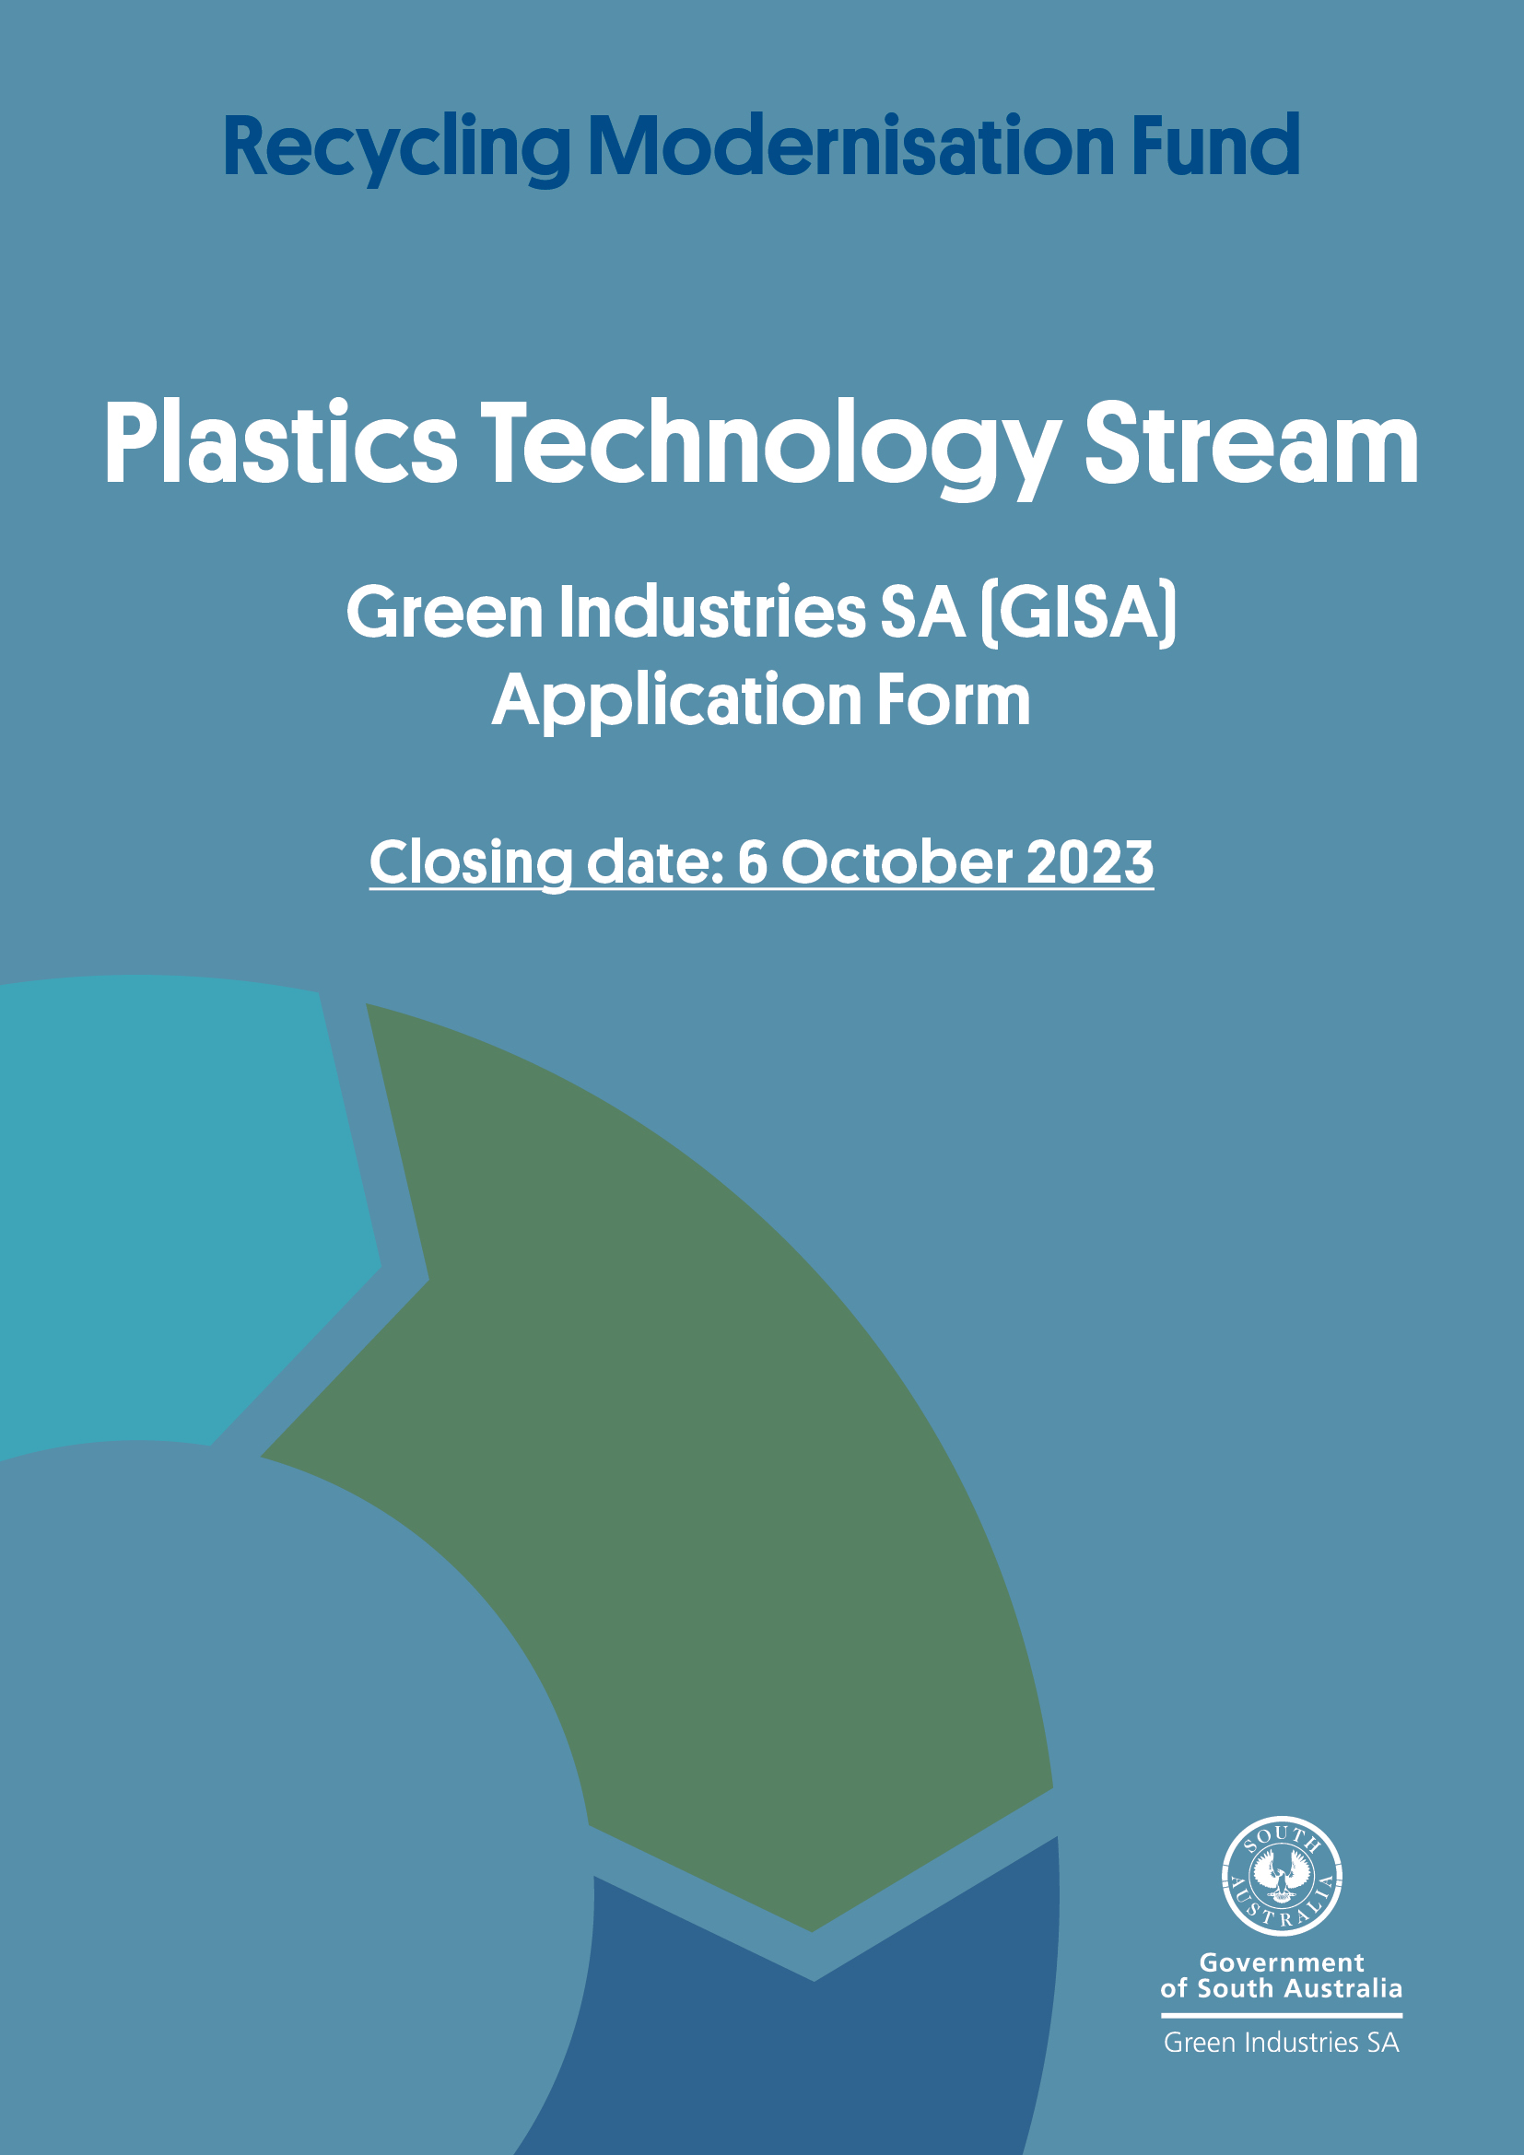

Contents

Section A: General information 3
Section B: Sole / lead project proponent details and eligibility 4
Section C: Consortium member project proponent details and eligibility 7
Section D: Project Eligibility 9
Section E: Project details 11
Section F: Additional project details for consortium proposals 15
Section G: Project budget and sources of funding 16
Section H: Additional funding questions for consortium proposals 19
Section I: Responses to Assessment Criteria 20
Section J: Checklist 24
Section K: Applicant declaration 25

Section A: General information
Purpose of the form | Applications for Commonwealth funding are only open for state and territory governments (applicants) to apply on behalf of industry.  To enable an application to the Commonwealth Department of Climate Change, Energy, the Environment and Water (DCCEEW), Green Industries SA (GISA) requires industry applicants to submit information about projects they want to implement that address plastic recycling rates and pollution by supporting advanced and innovative technologies targeting hard-to-recycle plastics. By supporting more advanced recycling technologies, we will unlock opportunity for hard-to-recycle plastics, boost our plastics recycling rates, and drive towards a circular economy for plastics.
Before applying | Read the Plastics Technology Stream Funding Guidelines provided by the department, available from the RMF Plastics Technology stream - DCCEEW.  Only states and territories (applicants) can contact DCCEEW to discuss the funding arrangements, eligibility criteria, and assessment process.
To complete the form | Save changes to this form on your computer.
Application must include | A completed and signed application form  Letter/s of support from all project proponent/s  Project Budget  Project Plan  Cost-Benefit and Financial Analysis  The abovementioned information will be included in your application if you complete the following form in full.  A letter of support from Green Industries SA will be included for supported projects once assessment is completed by GISA
Closing date | 5pm AEST, 6 October 2023 (as GISA will seek Board and Ministerial approval before submitting successful applications to DCCEEW by 13 November 2023)
Email the complete application form | Justin.lang@sa.gov.au
For more information | Phone: 0419 948 931

Section B: Sole / lead project proponent details and eligibility

- Does the project have an eligible project proponent, or lead eligible project proponent if applying as a consortium?

Yes
No
Please note that eligible project proponent/s, including the lead project proponent:
- should have a current Australian Business Number (ABN) or Australian Registered Body Number (ABRN)
- should be registered for GST
- must not be trading while insolvent
- must not have owners/directors who are an undischarged bankrupt.
- Is the sole / lead project proponent (select one):
an Australian entity or partnership incorporated under the Corporations Act 2001 (Cth)
an entity or partnership under the Corporations (Aboriginal and Torres Strait Islander) Act 2006 (Cth)
an Australian research institution (can be a tertiary education institution, a government agency established for research, a cooperative research centre, an institute or centre of research or a privately owned and accredited research facility). Consultancies are not considered to be research institutions
a council, regional organisation of councils or other local government-controlled organisation
a non-government/not-for-profit organisation (must comply with the Australian Taxation Office’s definition) with an established legal status, or those without legal status that can have grant funds administered by another organisation with legal status
an Aboriginal Land Council.

- Sole / lead project proponent details:
Organisation name
Entity type
ABN / ABRN
Registered for GST (Y/N)?
ACN (if any)
Is this the sole or lead project proponent (Y/N)?
Postal Address
Organisation phone number
Name of project proponent contact
Role of project proponent contact
Address of project proponent contact (if not as above)
Office number of proponent contact
Mobile number of project proponent contact
Email of project proponent contact
Name of alternative contact
Role of alternative contact
Address of alternative contact (if not as above)
Office number of alternative contact
Mobile number of alternative contact
Email of alternative contact

- Provide a brief background of the project proponent’s business activities including specific experience and involvement in the plastics recycling industry and supply chain (max 300 words)

- Has the sole or lead project proponent received any statutory environmental or safety breach notice issued within the last three years?
Yes Go to question 6.
No Go to question 8.

- If yes, has the breach been rectified (if yes, please attach evidence)?
Yes Go to question 7.
No

- Describe and attach evidence of how, they are working to effectively resolve the breach. Include a description of the breach in your response.

- Has the project proponent been subject to prosecution or a statutory notice from the Fair Work Ombudsman for industrial relations enforcement action in the last three years?
Yes Go to question 9.
No Go to question 11.

- If yes, has the non-compliance been rectified (if yes, please attach evidence)?
Yes Go to question 10
No

- Describe and attach evidence of how they have rectified the non-compliance. Include a description of the breach in your response.

- Does the applicant plan to undertake the project activity as part of a consortium?
Yes Complete Section D.
No Skip to Section E.

Section C: Consortium member project proponent details and eligibility
Complete this section for EACH of the consortium members.
If the project is not to be delivered by a consortium, skip to Section E.
- Additional (non-lead) project proponent details (add one for each proponent):
Organisation name
Entity type
ABN / ABRN
ACN (if any)
Postal Address
Organisation phone number
Name of project proponent contact
Role of project proponent contact
Address of project proponent contact (if not as above)
Office number of proponent contact
Mobile number of project proponent contact
Email of project proponent contact
Name of alternative contact
Role of alternative contact
Address of alternative contact (if not as above)
Office number of alternative contact
Mobile number of alternative contact
Email of alternative contact

- Has the project proponent received a statutory environmental or safety breach notice issued within the last three years?
Yes Go to question 3.
No Go to question 5.

- If yes, has the breach been rectified (if yes, please attach evidence)?
Yes Go to question 5. No Go to question 4.

- Please describe, and attach evidence, they are working to effectively resolve the breach. Include a description of the breach in your response.

- Has the project proponent been subject to prosecution or a statutory notice from the Fair Work Ombudsman for industrial relations enforcement action in the last three years?
Yes Go to question 6. No Go to Section E.

- Has the non-compliance been rectified (if yes, please attach evidence)?
Yes Go to question 7. No

- Describe, and attach evidence, they have rectified the non-compliance. Include a description of the breach in your response.

Note
An applicant (GISA) may determine that project activity is best achieved through the use of a consortium arrangement.

If the application is successful, the lead proponent will be offered a Grant Agreement with the state or territory as the lead agency and be responsible for all obligations contained in the Grant Agreement's terms and conditions. This includes monitoring, management, financial performance, service outcomes and insurance coverage.

Please attached a letter of support from the project proponent. The letter must include:
- Details of the project proponent;
- An overview of how the project proponent will work with the lead project proponent and any other project proponents in the group to successfully complete the project;
- An outline of the relevant experience and/or expertise the project proponent will bring to the group;
- The roles/responsibilities the project proponent will undertake, and the non-financial resources it will contribute (if any);
- The proponent’s financial contribution towards the project (if any), and the arrangements that will be in place to ensure the commitment is delivered; and
- Details of a nominated management level contact officer.

Section D: Project Eligibility
- Does this application relate to a proposal to increase the recovery and recycling rates of hard-to-recycle plastics (plastics with low recovery and recycling rates due to difficulties in recycling; and for which there is currently limited infrastructure and technology to support circularity in the supply chain) and promote the objectives of a safe circular plastics economy?
Yes No

- Does this application relate to:
An advanced recycling project targeting hard-to-recycle plastics, such as mixed, multi-layer, flexible or contaminated plastics
Commercialisation or scaling-up of emerging and trial technology targeting circularity of hard-to-recycle plastics
An infrastructure upgrade and technology to extract and process plastics contained within products, such as e-waste, into higher-value products
A proposal to equip existing or new material recovery facilities or plastic recovery facilities with sorting, separation and de-contamination technology such as optical or robotic machinery to increase the diversion of plastics from landfill
A proposal put forward by a consortium proposing end-to-end solutions and circularity in our plastics supply chain.
Other (describe below)

- Does the proposal relate to one or more of:
new infrastructure, technology, processes, machinery and/or equipment to recycle hard-to-recycle plastics
an improvement or expansion of existing infrastructure, technology, processes, machinery and/or equipment to recycle hard-to-recycle plastics
commercialisation or scaling up to build or increase existing capacity for recovering and recycling hard-to-recycle plastics.

- GISA to answer: Does this application have the written support of the responsible state or territory Minister, or a delegated senior executive from the state or territory government (note: this may be a single letter that covers each of the applications submitted by the applicant)?
Yes Please also provide a copy of the letter with the application.
No
- Does the application demonstrate avoidance, mitigation and management measures for potential environmental impacts resulting from the project including carbon emissions?
Yes
No

- Will the project be economically viable over its operational life?
Yes
No
Describe

Financial viability of the company and of the project
Demonstrate that an objective assessment on the financial viability for the company and the product has occurred. Provide a summary of the expected short and long term costs and benefits of the project (this can form a separate attachment). Changes to commodity stock prices should be considered if relevant to the viability of the project.

- Does the application demonstrate at least a 50% contribution towards eligible project costs from the project proponent, or in the case of a consortium proposal, each of the project proponents who are part of the consortium?

Yes
No

- Will the project be commissioned and operational by no later than 30 June 2027?
Yes
No

- When will the project be commissioned and operational?

Section E: Project details

- Project title (max 15 words)

- Short project description (max 50 words)

- Project address (If there are multiple sites where project activities will be undertaken, please add each address)

- What are the project’s scope and the key activities? (max 300 words)

- What will finances provided through the Plastics Technology stream be used for? (max 300 words). Detailed budget items should be listed in section H.

- What plastic polymer(s) is being targeted by the project?

- Why is the plastic a hard-to-recycle plastic (see 1.3 of the Guidelines)? (max 300 words)

- What are the expected environmental, economic, and social benefits for the project (max 500 words)

- GISA to complete: Detail any complementary actions being undertaken by the state/territory government that will support the project, and any Commonwealth or state and territory regulatory approvals which are in place or will be needed for the project to go ahead (max 300 words)

- Description of the type of plastic waste that will be used as an input for processing and any minimum standards, quality, or contamination requirements for this material to be viable (including for end products to meet current Australian Standards and/or state and territory guidelines and policies) (max 300 words)

- How will the plastic to be used as feedstock for the project be sourced? Please include information about expected transport arrangements/costs and security of supply (max 500 words)

- What arrangements will there be to ensure there is a market for the material produced by the project? (max 300 words)
12a Please list end markets or users for the recovered material and their location.

12b What assumptions are being made, if any in terms of market demand for products? Please provide any evidence or data analysis to support the assumptions.

- Estimated project start and completion dates
Start date
Completion Date

- (a) Indicative project milestones
Milestone payment | Description (examples listed below) | Completion date
Milestone 1 | Planning and environmental approval process completed
Milestone 2 | Order placed for equipment
Milestone 3 | Equipment delivered to the work site.
Milestone 4 | Construction/installation completed
Milestone 4 | Testing / trials
Milestone 5 | Commissioning / completion
Milestone 6 | Launch / production

14 (b) KPIs: The applicant must demonstrate that deliverables that have been established for the project are based on sound metrics, are realistic and measurable. For estimated outcomes please provide a baseline and identify measurable values or targets
Product value and local benefits
Key performance indicators
e.g. product value, sales value, environmental impacts
Estimated outcome/target | Baseline  e.g all materials are exported overseas | Targets  e.g 30% or x tonnes of the product received to be processed locally
How will the indicators be measured?

When will the indicators be measured?

Reduction of waste to landfill and/or targeting of products that are banned from landfill under the Waste EPP (for multiple products please list all)
Key performance indicators
e.g annual tonnage of waste diverted, number of T.Vs received or processed.

Estimated outcome/target | Baseline  e.g processing of 50 TVs per month | Targets  e.g 20% increase in the number of TVs processed
How will the indicators be measured?
Please list all material types which will be measured resulting from this project.

When will the indicators be measured?

- (a) What is the estimated additional volume of plastic waste that will be processed in the three years after the project is commissioned and operational (tonnes/annum; by polymer if multiple polymers will be targeted)?
Years after project commissioned and operational | Polymer type | Processing capacity
Year 1
Year 2
Year 3

15 (b) Current activity and expected outcomes
 | Mixed C&I tonnes | Mixed MSW tonnes | Source separated tonnes | Total tonnes
Current quantity of material received p.a.
Current processing throughput of material p.a
Current quantity of material diverted from landfill p.a.
Current quantity waste disposed to landfill p.a.
Expected additional yield of material rec’d p.a.
Expected additional throughput p.a.
Expected additional quantity of material diverted from landfill p.a.
Expected quantity disposed to landfill p.a.
Where/who do you expect to source the additional material from? |  |  |  | -

- How many full-time equivalent (FTE) jobs are estimated to be created during the construction phase of the project?

- How many ongoing FTE jobs are estimated to be created following completion of the project?
Additional employees expected as a result of this project (no. FTE): x unskilled,
x machinery operator, x driver, x technical support, x administration
x sales / marketing, x supervisor

Section F: Additional project details for consortium proposals
Only complete this section if the project is to be delivered by a consortium.
If not, skip to the next section.
- How will the arrangements between the consortium members be overseen by the lead project proponent? (max 300 words)

- Describe the governance arrangements of the consortium parties if the project is successful (max 300 words)

- Describe the legal arrangements of the consortium parties if the project is successful (max 300 words)

Section G: Project budget and sources of funding
- What is the total project cost?
Financial year | Amount  ($ GST excl)
2023-24
2024-25
2025-26
2026-27
Total

What key infrastructure / plant and equipment is required to ensure the project can be commissioned? Please provide a description of all the items required for the project (excluding in-kind contributions). Please add additional lines if required. Quotes for capital items should be attached. Please itemise these, including budget items associated with commissioning in the following table:
Equipment / item description | Delivery date | Estimated cost | In kind contribution
 | TOTAL: | $ | $
Please include 1-2 page specifications for significant equipment / infrastructure as an attachment.

- If successful, of the total project cost, how much will the project proponent(s), state or territory applicant, Plastics Technology stream funding and any other Commonwealth funding contribute?
Financial year | Proponent(s)  ($ GST excl) | State or Territory*  ($ GST excl) | Plastics Technology stream*  ($ GST excl) | Other Commonwealth government*  ($ GST excl)
2023-24
2024-25
2025-26
2026-27
Total
*Applicants should indicate the SA Govt and Commonwealth funding requests, noting that GISA will determine this after the close of applications.
- If successful, describe what the Plastics Technology stream funding will be used for in each financial year?
Financial year | What the funding will be used for
2023-24
2024-25
2025-26
2026-27
Total

- Describe any other confirmed or possible sources of funding for the project from the Australian Government? This includes funding received or applied for the project. You may be required to provide evidence of other Commonwealth funding sources.
Commonwealth department name | Description/program name | Amount  ($ GST excl)
 | Total

If the project is funded through other sources please provide details (for multiple funders please list all funders separately):
- Name of funding body:

- Contact details for funding body:
- Funding amount: $

- Please provide date this funding was approved or expected notification date:

- Name and contact details for funding program:

Please provide a breakdown of any in kind contributions
Project element | Organisation providing in kind contribution | Value of in-kind contribution
 |  | $
 |  | $
 |  | $
 | Total value of in-kind contribution | $
 | Total project budget | $

Section H: Additional funding questions for consortium proposals
Only complete this section if the project is to be delivered by a consortium.
If not, skip to the next section.

- How much will each proponent contribute (provide attachment if more than 4)?
Financial year | Name 1  ($ GST excl) | Name 2  ($ GST excl) | Name 3  ($ GST excl) | Name 4  ($ GST excl)
2023-24
2024-25
2025-26
2026-27
Total

- What arrangements will be put in place to ensure consortium members meet their commitments?

Section I: Responses to Assessment Criteria
- Alignment of the project with program objectives (max 2000 words)
Demonstrate this by describing:
  - the increase in Australia’s recycling and recovery rates of hard-to-recycle plastics that will be delivered by the project
  - the strategic benefit of the project for Australia, and for the jurisdiction
  - how the project will achieve the objectives and intended outcomes of the Plastics Technology stream
  - the material targeted by the project and why it is a hard-to-recycle plastic
  - the nature, extent and timeliness of anticipated outcomes and the benefits of the project
  - why the Australian Government should invest in the project, including how the project represents value for money.
1a
1b

- Benefits to Australia’s safe plastics circular economy, or contribution to managing plastics where circularity is not an option (max 2000 words)
Demonstrate this by identifying:
  - the extent to which the project clearly identifies and provides evidence of reliable feedstock and an end market that retains resources in the economy
  - if applicable, the extent to which the feedstock for the project will be sourced from regional and remote locations, including from other states and territories
  - if applicable, how the project will develop and contribute to ongoing and sustained collaborations to build a safe circular economy for plastics
  - the extent that the project will maximise Australian employment outcomes, such as increased jobs and/or a more highly skilled workforce over the life of the project and into the future
  - the extent to which infrastructure funded through the program is designed and delivered to reduce environmental impact, such as through minimised carbon emissions, the use of recycled materials, and sound waste management practices
  - how the project will create and retain other benefits for Australia, including IP or new skills.
2a
2b

- Capacity, capability and resources to deliver the project (max 2000 words)
Demonstrate this by identifying:
  - the plan to manage and deliver the project
  - track record and experience of project proponents in managing projects of a similar nature or scale
  - where the application relates to a consortium, the arrangements to ensure each proponent delivers on its commitments throughout the life of the project
  - access, or plan to ensure future access, to any required infrastructure, equipment, technology, commercial agreements, IP etc
  - risks identified and proposed mitigation strategies (refer matrix below)
  - clear process for monitoring and reporting on the project.
3a
3b

3(e). Applicants must identify potential risks to the project’s achievements using the risk matrix below. The outcomes listed must be assessed as a minimum. Add or delete lines specific to the project if required.
Outcome | Likelihood  (High/Med/Low) | Impact  (High/Med/Low) | Risk / Threat  (Critical/High/Med/Low)
Delays in planning and environmental approvals
Delays in shipment of equipment
Overrun of budget
Lack of market
Equipment performance does not meet expectations
Loss of key personnel
Other:

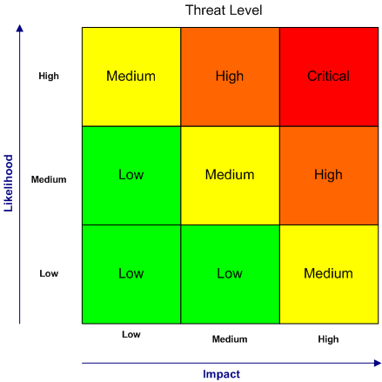
For risks identified as medium, high and critical please describe actions or strategies to minimise these risks.

- Managing environmental impacts, and contribution to traceability of waste materials (max 1000 words)
Demonstrate this by identifying:
  - management and reporting of any environmental impacts that may result from the project, including the adoption of measures to minimise carbon emissions of operations and other environmental release of materials
  - how the project will achieve and report on end-to-end traceability (from source/aggregation point to final use) of the targeted plastic feedstock.

- Access to finance and investment (max 1000 words)
Demonstrate this by identifying:
  - the private sector investment the funding will leverage
  - the state / territory government investment the funding will leverage
  - the project proponents’ access, or future access, to the required finance and investment to fund their share of eligible project costs
  - if applicable, intended funding arrangements to support ongoing collaborative activities.
5a
5b

Section J: Checklist

All relevant sections of the form been completed

The application includes the mandatory attachments:
Letter/s of support from each project proponent(s)

Project Budget
Project Plan
Cost-Benefit and Financial Analysis
(if relevant) Evidence of remediating environmental or safety breach
(if relevant) Evidence of remediation of industrial relations non-compliance

If the application includes any additional supporting information or attachments, please list them here:

Section K: Applicant declaration
To be completed by an authorised representative of the applicant.
I declare that the information I have provided in this application is true and correct to the best of my knowledge. I understand that providing false or misleading information is an offence.
I declare I have read and accepted the conditions outlined in the Plastics Technology Stream Funding Guidelines.
I understand that the Australian Government may make media and other public announcements in relation to the application.
I understand that if the project is supported, my government must comply with Department of Climate Change, Energy, the Environment and Water communication protocols governing publicity about the project.
I declare that where a third party’s personal information is contained in this application, the third party has been informed and has consented to provide their information for the purpose of this application.
Signature:
Date (dd/mm/yyyy):
Full name:
Title:
Phone:
Email:

Section L: Privacy notice
The department collects personal information (as defined in the Privacy Act 1988) in relation to this application form for the purposes of assessing the application for funding and providing advice to the Australian Government. If the relevant personal information requested in this application is not provided, we may not process the application.

The department is bound by the Australian Privacy Principles in the Privacy Act 1988. We respect project proponent (s) rights to privacy under the Privacy Act and we will comply with the requirements under the Act in respect of the collection and management of the personal information. The department’s Privacy Policy contains information about how to access or correct project proponent (s) personal information or make a complaint about a breach of the Australian Privacy Principles. The Policy is available at: www.agriculture.gov.au/about/commitment/privacy.

The department may share the information state/territory government provide to technical experts and other government agencies for a relevant Commonwealth purpose such as:
- assessing and making decisions on applications
- improving the effective administration, monitoring and evaluation of Australian Government funding
- for research
- to announce the awarding of funding
- providing the disclosure is consistent with relevant laws, particularly the Privacy Act.
The department will treat the information state/territory government provide as sensitive and therefore confidential if it meets all of the following conditions:
- State/territory government clearly identify the information as confidential and explain why the department should treat it as confidential
- the information is commercially sensitive
- disclosing the information would cause unreasonable harm to state/territory government or someone else
- state/territory government provide the information with an understanding that it will stay confidential.
By completing and submitting this form state/territory governments consent to the disclosure of all information (including personal information) contained in this form as set out above.

Total project budget is the total cost of the project plus in kind contributions.

